My code is a little messy so I tried cleaning it up a bit:

Import numpy and matplotlib

#python code for reading in the data for Lab #2

filename = 'SHVnew.txt'

data = np.genfromtxt(filename, delimiter=',',skip_header=1)

press_mb=data[:,1]

height_m=data[:,2]

temp_C=data[:,3]

dewpt_C=data[:,4]

print(data)

#press_mb=data

#height_m=data

#temp_C=data

#dewpt_C=data

#Define constant

Rd = 287

#Change units

temp_K = temp_C + 273.15

height_km = height_m/1000

press_Pa = press_mb*100

dewpt_K = dewpt_C + 273.15

**To calculate density:** density = press_Pa/temp_K/Rd

print(density)

print(density[0])

0.3551681658724209

**To print lowest layer temp, density, pressure:**

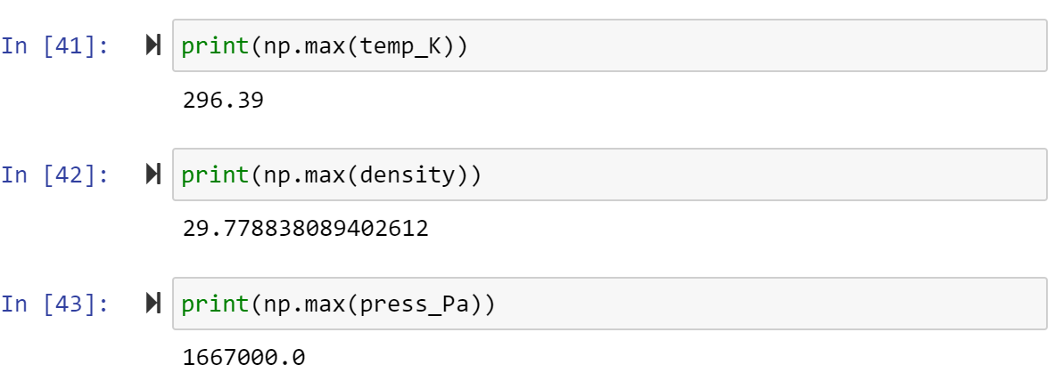

**Plotting temp and dewpoint vs height:**

plt.plot(temp_K, 'r', dewpt_K, 'g', height_km, 'b')

plt.xlabel(height_km)

plt.ylabel('Temperature and Dewpoint')

plt.title('Temperature and Dewpoint (red and blue) vs. height (green)')

print('Max value of dewpoint', max(dewpt_K))

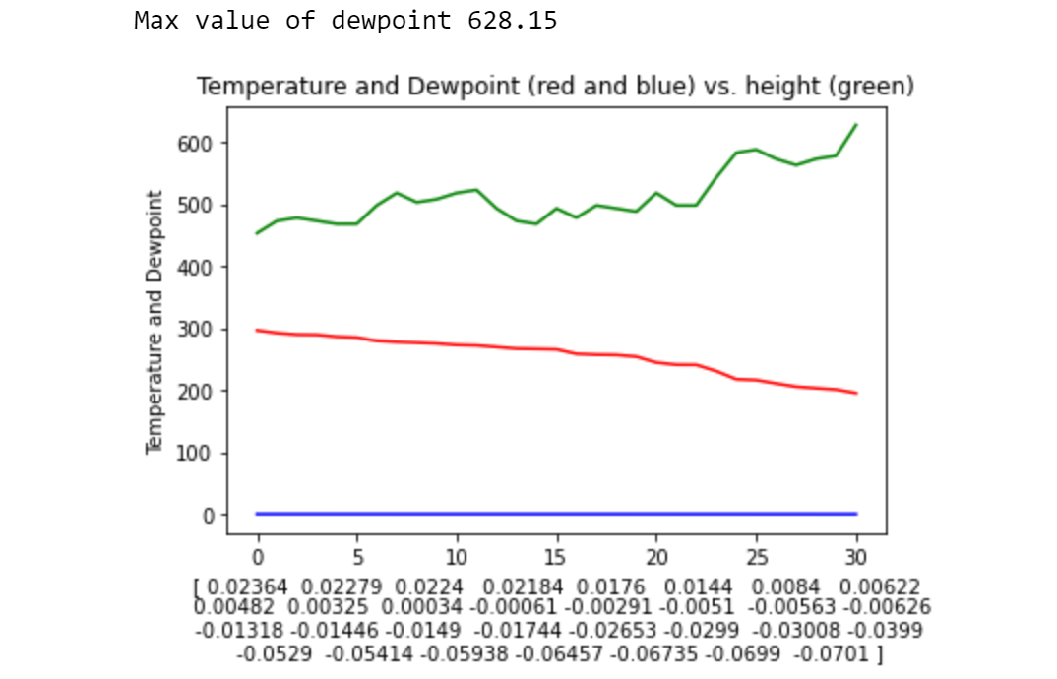

Note: it is incredibly odd that height is stuck at y = 0. I got this error:

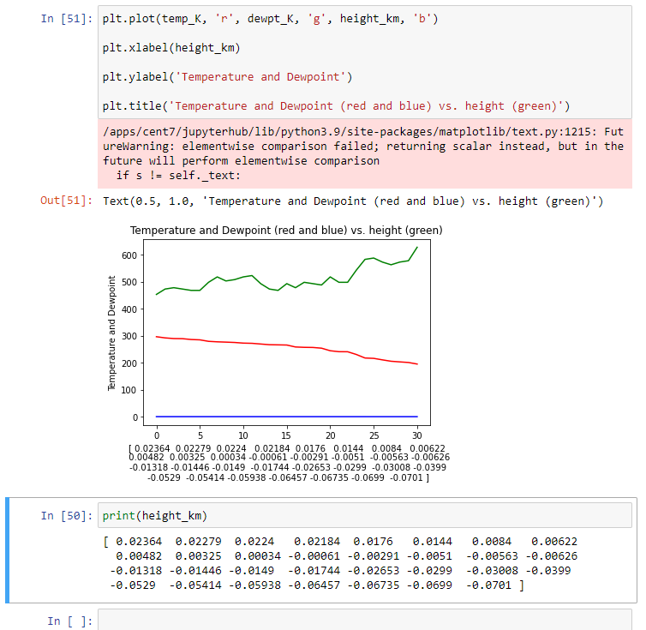

I’ve tried changing around the variables and everything. My values for height also look incredibly wrong. I don’t mind losing points off for this, but I would like to know in the feedback what is wrong with my code or what could be improved.

**#2**

temp_F = (temp_K - 273.15)*(9/5) + 32

dewpt_F = (dewpt_K - 273.15)*(9/5) + 32

dewd = temp_F - dewpt_F

print(np.mean(dewd))

plt.plot(dewd, 'r', height_km, 'b')

plt.xlabel(‘height_km’)

plt.ylabel(‘dewd’)

plt.title('dewpoint depression (red) vs. height (blue)')

print(‘Max value of dewpoint’, max(dewpt_F))

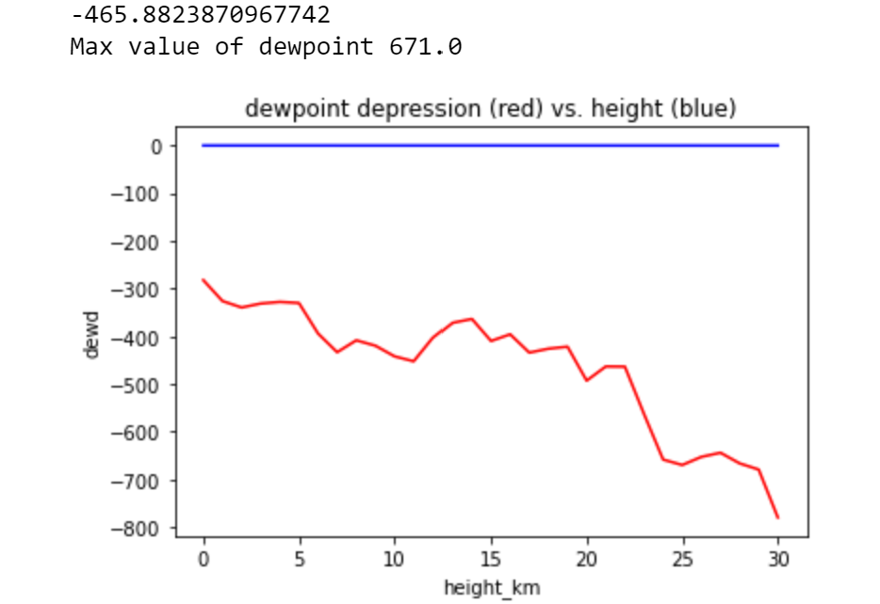

**#3**

#I’m assuming that we switch back to Kelvin for this. Simply because the calculation for H should include kelvin so it would be weird to not use it for all of #3

plt.plot(temp_K, 'r', height_km, 'b')

plt.xlabel('Height (km)')

plt.ylabel('Temperature (K)')

plt.title('Temperature (red) vs. height (blue)')

print('Max value of Temperature, max(temp_K))

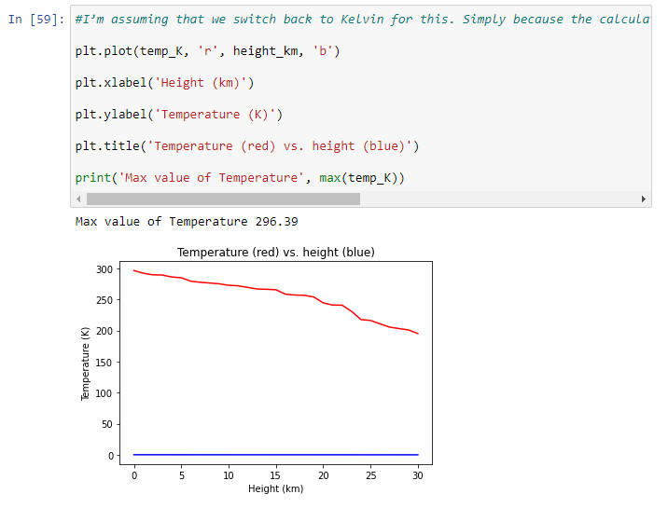

**To calculate mean temp:**

meantemp_K = print(np.mean(temp_K)): **254.48774193548385**

g = 9.81

H = (Rd * meantemp_K)/g: **7445.258097398967**

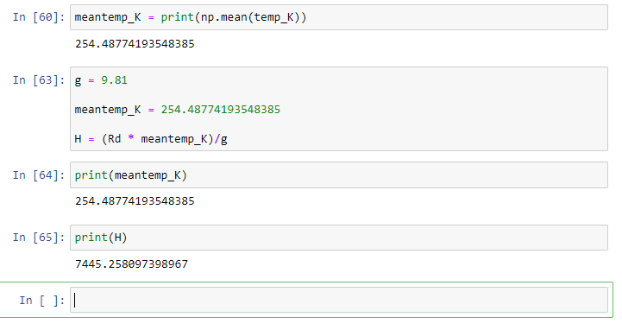

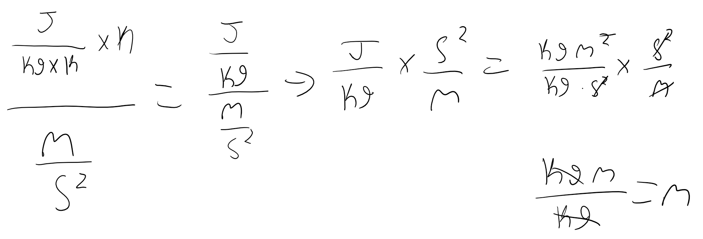

5. Since I already have the scale height formula, all I have to change is the temperature value. Therefore:

print(np.max(temp_K))

maxtemp_K = 296.39

H = (Rd * maxtemp_K)/g

print(H): **8671.144750254842**

Since my data is a little odd, for the lowest layer, I’m using the max temp. For the top layer, I’m using low pressure.

1. From equation in (1), we get

**My code to find zbot:**

e = 2.718281828459045

(minpztop) = (np.min(press_mb))

print(minpztop)

maxpzbot = (minpztop) * (e**(180/H2))

Output: **302.12**

I can’t seem to figure out how to plot the modelled pressure. For the pressure vs height graph, my code is:

plt.plot(press_Pa, 'r', height_km, 'b')

plt.xlabel('Height (km)')

plt.ylabel('Pressure (Pa)')

plt.title('Pressure (red) vs. height (blue)')

**Output:**

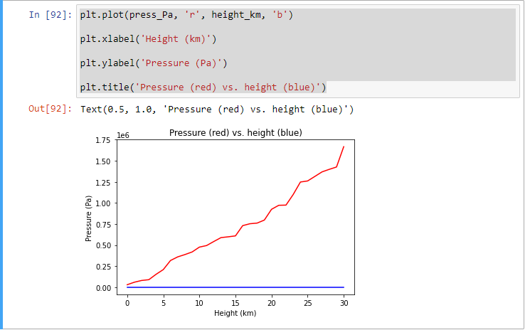

**I believe this is all I have to include :D**